## Final Year Project



**Project Name:**

**Travel Assistant**

**Session:**

**Fall 2022**

**Project Advisor:**

**Dr.Amjad H.Zahid**

**Submitted by:**

|  |  |
| --- | --- |
| **Name** | **ID** |
| **Ehsan Ali** | **F2019065021** |
| **Aleena Aftab** | **F2019065227** |

**University of Management and Technology**

**C-II Johar Town Lahore Pakistan**

**Dedication**

First, of all we will dedicate every word of this study to our ALMIGHTY ALLAH

Who gave this knowledge and strength to face everything in life? And also to our beloved parents whose love is softer than anything else, who always pray for our success

## 

**Final Approval**

**Panel of Examiners**

* **Head of Department**  ______________________

Department of Software Engineering

University of Management and Technology

Lahore

* **Program Director (Final Year Projects)** ______________________

Department of Software Engineering

University of Management and Technology

Lahore

* **Supervisor** ______________________

Department of Informatics and Systems

University of Management and Technology

Lahore

**Project Title** Travel Assistant

**Objective** Web Based Appliction project

**Undertaken by** Ehsan Ali

Aleena Aftab

**Supervised by** Dr. Amjad Husain Zahid

**Starting Date** September 30, 2022

**Completion Date**

**Tools Used: (**Html, CSS, Java Script, PHP)

**Operating System** Window-10

**Declaration Form**

I have carefully examined the documentation of the Final Year Project titled *“Project title”*; and I endorse that this documentation complies with the standards of an undergraduate level Final Year Project report.

The document has been checked for plagiarism through Turnitin software available in UMT Library. The similarities of the document are within acceptable range.

Moreover, the accompanying CDs contain PDF of the documentation, as well as the source code and binaries with user manual and installation guide.

**FYP Advisor Name: ______________________________**

Signature: __________________ Date:___________________

**Abstract**

Traveler Assistant is a web application. The main purpose of "Traveler Assistant" is to guide how to conveniently book hotels, and tickets buses and for the purpose of tours. The goal of this project is to develop a system that automates the processes and activities of a travel agency. In this project, we will make it easier for you to find seats and book a train, or bus. In the current system, the customer has to contact various agencies to find out the details of the seats and book the tickets. We provide access skills to critically examine how the tourist visits and their capacity to act appropriately in addressing the consequences of tourism, locally, regionally and nationally, including visitor safety and environmental impacts. It provides benefits for the customer to plan a specific journey and have it properly executed. The 'Tours and Travels Management System' project is developed to replace the existing system which helps in keeping records of the customer's destination details as well as payments received.

.

Revision Chart

| Version | Primary Author(s) | Description of Version | Date Completed |
| --- | --- | --- | --- |
| *Draft* | Ehsan Ali | Initial draft created for distribution and review comments | (To be decided) TBD |
| *Preliminary* | TBD | Second draft incorporating initial review comments, distributed for final review | TBD |
| *Final* | TBD | First complete draft, which is placed under change control | TBD |
| *Revision 1* | TBD | Revised draft, revised according to the change control process and maintained under change control | TBD |
| *Revision 2* | TBD | Revised draft, revised according to the change control process and maintained under change control | TBD |
| *Etc.* | TBD | TBD | TBD |

# Contents

Contents 1

Definitions and Acronyms 3

List of Figures 4

List of Tables 5

1. Introduction 6

1.1 Motivations 6

1.2 Project Overview 6

1.3 Problem Statement 6

1.4 Objectives 6

2. Domain Analysis 7

2.1 Customer 7

2.2 Stakeholders 7

2.3 Affected Groups with social or economic impact 7

2.4 Dependencies/ External Systems 7

2.5 Reference Documents 7

2.5.1 Related Projects 7

2.5.2 Feature Comparison 8

3. Requirements analysis 9

3.1 Requirements 9

3.2 List of Actors 10

3.3 List of use cases 10

3.4 System use case diagram 10

3.5 Extended use cases 10

3.6 User interfaces (mock screens) 12

4. System Design 15

5.1 System Architecture Diagram 15

5.2 Class Diagram 16

5.3 Collaboration Diagrams 17

5.4 Other UMLs 18

* 1. ERD 18

## Introduction

## Traveler Assistant assists the travel manager with planning, monitoring, and analyzing business trips. Typically, it refers to a management platform that provides reporting, travel policy, and inventory of trip. However, it can also be used to describe the entire procedure of handling business travel.

## Motivations

## We are motivated and inspired to visit all kinds of website. In comparison to the average weekly salary of $1,230 for all occupations, you will make about $1,080 as a travel assistant. You may anticipate working 39 hours on average each week, just under the national average of 40 hours. A quarter of travel agencies also have part-time employees. It's also important to note that women make up roughly 80% of the travel industry in Australia. Australia as a whole has open positions, with the majority located in NSW, Victoria, and Queensland. Call center jobs are also available, albeit the majority of opportunities are office-based.

## Project Overview

Traveler Assistant website this one of the website that will help customers to book Buses tickets through this travel agency website. It is really simple and hassle-free to purchase tickets. One of the intriguing designs to work on and finish in the real world will be this one. Some people enjoy taking the bus, rail, or any other mode of transportation when they travel. It is possible to book a train or a ticket to the destination on the website of the tour management system, which is designed for a travel agency. The travel management system application is designed for a travel agency, where it is possible to reserve train or buses tickets with a description of the intended trip.

**Following are the sample artifacts for this section:**

## Problem Statement

Consider yourself a system analyst for a travel company whose clients' travel arrangements are your responsibility. It assists customers with ticket purchases, hotel reservations, and auto rentals. You have been asked to assess the demands and design of the software system the organization needs for their operations. The system supports four different consumers, hotel, and automobile rental firm types. The list of available hotels, cars, and airline tickets can be requested by the customer. For each buses ticket, the client is interested in the following information:

## Objective

Travel assistants help travel agencies with tasks like delivering information to tourists, keeping up knowledge of tourist attractions, ensuring group travel assistance, leading tours, securing pleasant lodging, and instructing visitors on points of interest.

# Domain Analysis

## Customer

## Customer is a strategic vision of the company for managing relationships with customers through a variety of marketing activities, plans, and actions with expert support and flexible practise to create benefits for both the business and the customer. This vision aims to attract relationships with both current and potential customers in order to motivate and develop customers.

## Stakeholders

|  |  |  |
| --- | --- | --- |
| **Stakeholder** | **Name** | **Role** |
| Project Manager | Ehsan Ali | Role in system manager. |
| Website Developer | Aleena Aftab | *The project manager’s job is to over sees the project’s process.* |
| Database Engineer | Ehsan Ali | *The web developer’s task is to ensure that the website is properly encoded* |
| Requirement Analysis | Ehsan Ali | *The objective of requirement analysis is to study that has been gathered and determine the actual facts and feasibility of these needs* |
| QA | Ehsan Ali | *The quality tester’s job is to ensure that the application works as expected.* |
| End user | Admin, passengers tourism | *They can perform task like book tickets, tours after join system.* |

Table 2.1

Table 2.1: list of stakeholders

The stakeholders in tourism destination are local residents, local companies, media, employees, government, competitors, tourists, business associations, activists and tourism developers.

## Affected Groups with social or economic impact

The economic impacts of tourism include improved tax and personal income, higher living standards and more job opportunities. Sociocultural impacts are associated with interactions between people with different cultural backgrounds, attitudes and behaviors, and relationships to material goods.

## Dependencies/ External Systems

Travel assistant depends upon salaries on their level of education,years of experience. It is capable of carrying out all tasks necessary to manage travel and cost claims for other employees.

## Reference Documents

### Related Projects

For us to develop the following related projects were found:

Travel Assistant provides intermediate support and assistance in case of an emergency

Bus booking system, Hotel Booking system, car and tour package system

### Feature Comparison

|  |  |  |  |  |  |
| --- | --- | --- | --- | --- | --- |
| Sr No. | Comparison Feature | FMS | BHMS | Profile  Update | remarks |
|  |  |  |  |  |  |
|  |  |  |  |  |  |
| 1  2  3  4 | Login  Profile Visit  Booking and Budget Calculator  Payment | Admin will enter the credentials to login the system  Admin can view profile to the registered users  User can book a tour using provided packages  User can select from different payment method | If there are multiple admins any other admins can only login once  No  No  No  No | Admin can only his/her profile  Admin can view the activities of the feedback, booking, images of the users.  User can book a tour using provided packages  Successfully paid | It is too good to understand admins login login it easily  Admin can view the activities of the travel agents  User can budget a calculator  He will get the receipt |

# Requirements analysis

## Requirements

**Functional Requirement:**

|  |  |  |
| --- | --- | --- |
| **#** | **Requirement** | **Description** |
| **FR1** | **ADD Packages** | The admin shall be able to add a new package in the system which is visible to the user. |
| **FR2** | **Update Package** | The admin shall update the existing package if any changes made into the tourism package according to the user requirement |
| **FR3** | **Delete Package** | Admin shall be able to delete the existing package if it can be out dated or its demand decrease from user end. |
| **FR4** | **Search Package** | Admin shall search the desire package which he want to view by package code or name. |
| **FR5** | **Book Tour Plan** | The user shall book tour plan according to their choice by searching list. |
| **FR6** | **Create Account** | The user shall create/sign UP into the system by adding their details like email, password, address ,id card and mobile number |
| **FR7** | **Login** | The user shall login into the system after sign up by providing their password and username/email by validating his/her name from database. |
| **FR8** | **Change Setting** | The user shall change their name password and provided detail by click on personal information Icon. |
| **FR9** | **Feedback** | The user shall share their feedback by adding their comment in the by clicking on comment button about his/her experience |
| **FR10** | **Payment** | System shall Provide the facility to user to pay online fare by adding their bank account or credit/debit card |
| **FR11** | **Reserve Seat** | The user shall reserve their seat according to their package plan which he/she can be choose |
| **FR12** | **See Seat Status** | The user shall be able to see his reserve seat status and package plan cost or route |
| **FR13** | **Recover Password** | System shall provide the facility to end user to recover their password when the forget |
| **FR14** | **Contact** | System shall provide the facility to contact with the staff whenever click on WhatsApp icon |
| **FR15** | **Logout** | User shall be able to logout from their account |

Table 3.1

**Non-Functional Requirement:**

|  |  |  |
| --- | --- | --- |
| **#** | **Requirement** | **Description** |
| **NFR1** | **Database Security:** | An unauthorized person shall not able to access the panel and database, do not read and write the information. It should maintain the security of the client’s payment method. |
| **NFR2** | **Reliability** | Traveler Assistant shall provide a reliable environment to both customers and owner. Admin shall be able to upload delete update new packages without any error. |
| **NFR3** | **Usability** | The traveler Assistant shall use PHP in designed for user friendly environment and ease of use. |
| **NFR4** | **Availability** | The traveler Assistant shall be available for 24/7 because it offers tourists reserved tour from different places so it should be available for 24 hours. |
| **NFR5** | **Efficiency** | When an online booking of travel implemented customer can have reserved packages in an efficient manner all the functionality perform faster without any error. |
| **NFR6** | **Privacy** | The website shall protect user information, data from theft. |

*Table 3.2*

## List of Actors

**User/Passenger:** This person performs all functional activity e.g. book tickets, book tours.

**Admin:** This person approved user request and update the tour and buses schedule.

**Bank:** This person is link as a receiving online payment.

**Stuff:** This person is work as agent for tour plantings.

## List of use cases

* **Log in:** Allow user to provide account information and access the restricted services.
* **Sign Up:** Allow user to access in website by confirmation of Phone Number, or email.
* **Ticket Booking:** User book ticket and select seat and pay payment online.
* **Tour Booking**: User Book tour his own chooser from given tour list.
* **Cancel Request:** User cancel request of booking before 24 hours.
* **Confirmation:** User can receive confirmation message of booking tour and tickets.
* **Feedback:** User share experience of her traveling.

## System use case diagram

## In diagram 3.1 we show pessenger work.

## D:\Project\user.jpg

Figure 3.1

Tour side use case diagram show in 3.2

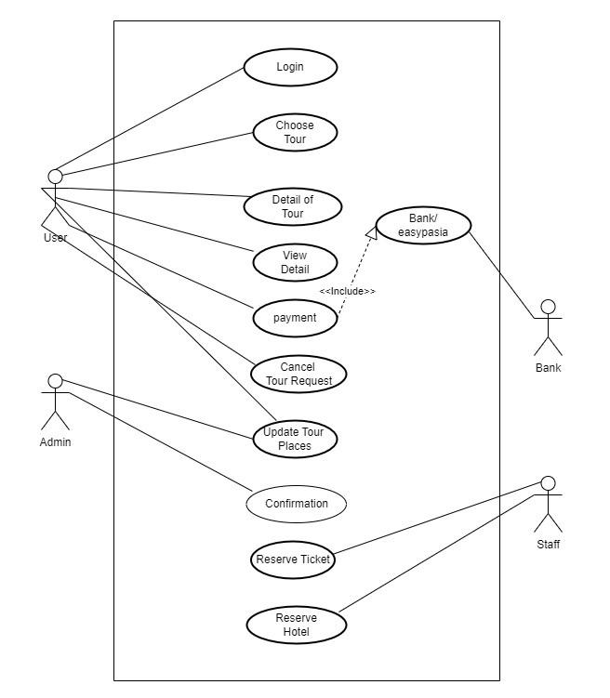Figure 3.2

Ticket booking use case diagram

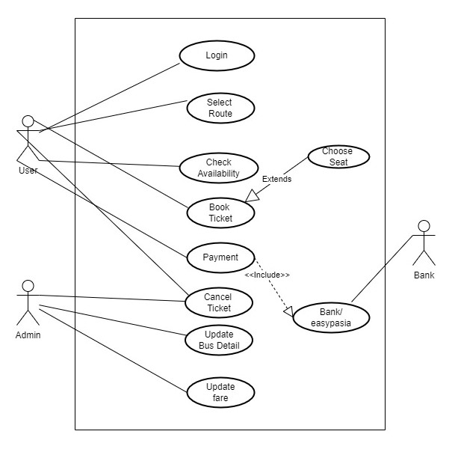Figure 3.3

Admin side use case diagram

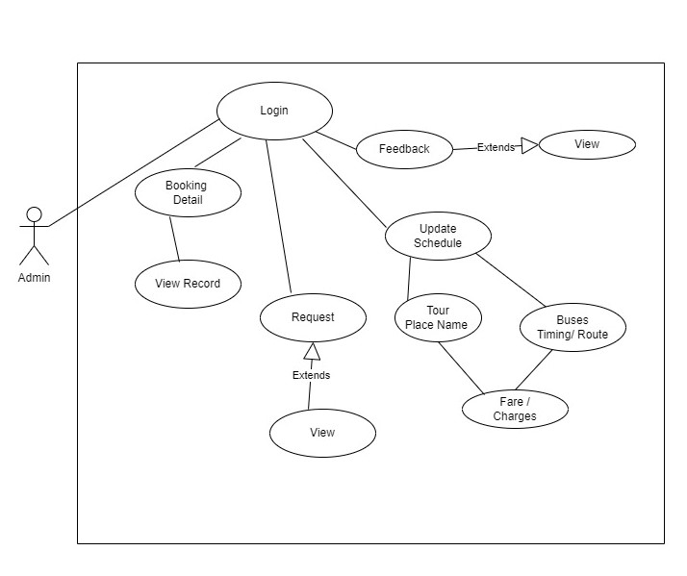Figure 3.4

## Extended use cases

|  |  |  |  |
| --- | --- | --- | --- |
| **Use Case ID:** | UC-1.2.1: Signup/Register | | |
| **Use Case Name:** | Register | | |
| **Created By:** | Ehsan Ali | **Last Updated By:** | Ehsan Ali |
| **Date Created:** | December 29, 2022 | **Last Revision Date:** | January 21, 2023 |
| **Actors:** | Passenger, admin , tourist . | | |
| **Description:** | The Actor will enter Registration Requirements for Register in our system. | | |
| **Preconditions:** | Actor must have valid required information for Register into the System. | | |
| **Post conditions:** | Actor Registration Data Will be saved. Database will be update. Actor will register into the System successfully. | | |
| **Normal Flow:** | 1. Actor enters First name for Registration. 2. Actor enters Last name for Registration. 3. Actor enters Password for Registration. 4. Actor enters Confirm Password for Registration. 5. Actor enters Phone Number for Registration. 6. Actor enters Location for Registration. 7. Actor will select the Register option. 8. System prompts the Actor for successfully Register into the System. | | |
| **Alternative Flows:**  **[Alternative Flow 1 – Not in Network]** | Not Applicable | | |
| **Exceptions:** | 1a. First Name field is empty.   1. The system shows an error message to the Actor and ask to enter valid First Name. This field cannot be empty.   1b. First Name field is containing numbers   1. The system shows an error message to the Actor and ask to enter valid First Name that is not contain numbers. This field cannot be invalid.   1c. First Name field is containing special characters   1. The system shows an error message to the Actor and ask to enter valid First Name that is not contain special characters. This field cannot be invalid.   2a. Last Name field is empty.   1. The system shows an error message to the Actor and ask to enter valid Last Name. This field cannot be empty.   2b. Last Name field is containing numbers   1. The system shows an error message to the Actor and ask to enter valid Last Name that is not contain numbers. This field cannot be invalid.   2c. First Name field is containing special characters   1. The system shows an error message to the Actor and ask to enter valid Last Name that is not contain special characters. This field cannot be invalid.   3a. Password field is empty.   1. The system shows an error message to the Actor and ask to enter valid Password. This field cannot be empty.   3b. Password field is not containing at least one special character.   1. The system shows an error message to the Actor and ask to enter Password that is containing at least one special character. This field cannot be invalid.   3c. Password field is not containing at least one Number.   1. The system shows an error message to the Actor and ask to enter Password that is containing at least one Number. This field cannot be invalid.   3d. Password field is not containing at least one Small Character.   1. The system shows an error message to the Actor and ask to enter Password that is containing at least one Small Character. This field cannot be invalid.   3e. Password field is not containing at least one Capital Character.   1. The system shows an error message to the Actor and ask to enter Password that is containing at least one Capital Character. This field cannot be invalid.   3f. Password field is not containing 8-digit.   1. The system shows an error message to the Actor and ask to enter valid 8-digit New Password. This field must contain 8-digit Password.   4a. Confirm Password field is empty.   1. The system shows an error message to the Actor and ask to enter valid confirm Password. This field cannot be empty.   4b. Confirm Password field is not match the above New Password Field.  The system shows an error message to the Actor and ask to enter confirm Password that is match the above Password. This field cannot be empty.  5a. Phone Number field is empty.   1. The system shows an error message to the Actor and ask to enter valid Phone Number. This field cannot be empty.   5b. Phone Number field is invalid.   1. The system shows an error message to the Actor and ask to enter valid Phone Number. This field cannot be invalid.   5c. Phone Number field is not containing 11-digit.   1. The system shows an error message to the Actor and ask to enter valid 11-digit Phone Number. This field must contain 11-digit phone number.   6a. Location field is empty.   1. The system shows an error message to the Actor and ask to enter valid Location. This field cannot be empty.   6b. Location field is invalid.   1. The system shows an error message to the Actor and ask to enter valid Location. This field cannot be invalid. | | |
| **Includes:** | None | | |
| **Frequency of Use:** | On Demand | | |
| **Assumptions:** | The Actor should know how to access the web page by using internet and log in by giving correct credentials. | | |
| **Notes and Issues:** | None | | |

Table 3.3

|  |  |  |  |
| --- | --- | --- | --- |
| **Use Case ID:** | UC-1.2.2:Login | | |
| **Use Case Name:** | Login | | |
| **Created By:** | Ehsan Ali | **Last Updated By:** | Ehsan Ali |
| **Date Created:** | December 29, 2022 | **Last Revision Date:** | January 21, 2023 |
| **Actors:** | Passenger, admin , tourist. | | |
| **Description:** | The Actor will enter credentials for login in our system. | | |
| **Preconditions:** | Actor must be signup into the System. | | |
| **Post conditions:** | Actor will log in successfully. System will Show the Home Page to the user. | | |
| **Normal Flow:** | 1. Actor enters Username for Log in. 2. Actor enters Password for Log in. 3. Actor will select the login option. 4. System validates if Actor is in the system record. 5. System prompts the Actor for successfully login. | | |
| **Alternative Flows:** | If Actor forget the password   1. The system will ask the Actor to enter phone number. 2. Actor will select the Reset Password option. 3. System will ask to the Actor to enter New Password. 4. System will ask to the Actor to enter Confirm New Password. 5. Actor will press the Change Password option. | | |
| **Exceptions:** | 1a. Username field is empty.   1. The system shows an error message to the Actor and ask to enter valid Username. This field cannot be empty.   1b. Username field is invalid   1. The system shows an error message to the Actor and ask to enter valid Username. This field cannot be invalid.   2a. Password field is empty.   1. The system shows an error message to the Actor and ask to enter valid Password. This field cannot be empty.   2b. Password is invalid   1. The system shows an error message to the Actor and ask to enter valid Password. This field cannot be invalid.   3a. Phone Number field is empty.   1. The system shows an error message to the Actor and ask to enter valid Phone Number. This field cannot be empty.   3b. Phone Number field is invalid.   1. The system shows an error message to the Actor and ask to enter valid Phone Number. This field cannot be invalid.   3.1c. Phone Number field is not containing 11-digit.   1. The system shows an error message to the Actor and ask to enter valid 11-digit Phone Number. This field must contain 11-digit phone number.   3.2a. New Password field is empty.   1. The system shows an error message to the Actor and ask to enter valid New Password. This field cannot be empty.   3.2b. New Password field is not containing at least one special character.   1. The system shows an error message to the Actor and ask to enter New Password that is containing at least one special character. This field cannot be invalid.   3.2c. New Password field is not containing at least one Number.   1. The system shows an error message to the Actor and ask to enter New Password that is containing at least one Number. This field cannot be invalid.   3.2d. New Password field is not containing at least one Small Character.   1. The system shows an error message to the Actor and ask to enter New Password that is containing at least one Small Character. This field cannot be invalid.   6.2e. New Password field is not containing at least one Capital Character.   1. The system shows an error message to the Actor and ask to enter New Password that is containing at least one Capital Character. This field cannot be invalid.   3.2f. New Password field is not containing 8-digit.   1. The system shows an error message to the Actor and ask to enter valid 8-digit New Password. This field must contain 8-digit New Password. | | |
| **Includes:** | Register | | |
| **Assumptions:** | The Actor should know how to access the web page by using internet and log in by giving correct credentials. | | |

Table 3.4

|  |  |  |  |  |
| --- | --- | --- | --- | --- |
| **Use Case ID:** | UC-1.2.3: Booking Tickets | | | |
| **Use Case Name:** | Booking Tickets | | | |
| **Created By:** | Ehsan Ali | | **Last Updated By:** | Ehsan Ali |
| **Date Created:** | December 29, 2022 | | **Last Revision Date:** | January 21, 2023 |
| **Actors:** | | **Primary Actor:** **Passenger** is primary actor that initiates use cases such as booking, browsing and cancel tickets of touring and traveling.  **Secondary Actor: Admin** is secondary actor that is initiates use cases such as update buses schedule and also overseeing user use cases. | | |
| **Description:** | | This use case allow booking tickets , browsing schedule of buses or tours and , booking tours. | | |
| **Preconditions:** | | 1. Customer has active his account and login it. 2. Customer has a select type to booking ticket and check availability. | | |
| **Post conditions:** | | 1. Customer receives confirmation message of booking. 2. Customer collect his seat number. | | |
| **Normal Flow:** | | 1. Actor inserts Information for sign Up. 2. Actor Login Website 3. System prompts customer to choice ticket. 4. System show detail of Buses. 5. System prompts user to select from these for traveling. 6. After That they make payment for confirmation of booking 7. System prompt confirmation after payment done. 8. After that user sign out from system. | | |
| **Exceptions:** | | 2a. In step 2 of the normal flow, if the Actor invalid payment.   1. Booking is disapproved 2. Message to customer to re-try Payment. 3. Customer make again payment successfully 4. Use Case resumes on step 3 of normal flow | | |
| **Includes:** | | 1. Register 2. For booking tickets first, we login in website then we book our tickets. | | |

Table 3.5

|  |  |  |  |  |
| --- | --- | --- | --- | --- |
| **Use Case ID:** | UC-1.2.4: Booking Tours | | | |
| **Use Case Name:** | Booking Tours | | | |
| **Created By:** | Ehsan Ali | | **Last Updated By:** | Ehsan Ali |
| **Date Created:** | December 29, 2022 | | **Last Revision Date:** | January 21, 2023 |
| **Actors:** | | **Primary Actor:** **Passenger** is primary actor that initiates use cases such as booking, browsing and cancel tickets of touring and traveling.  **Secondary Actor: Admin** is secondary actor that is initiates use cases such as update buses schedule and also overseeing user use cases. | | |
| **Description:** | | This use case allow booking tours , browsing schedule of tours and , booking tours. | | |
| **Preconditions:** | | 1. Customer has active his account and login it. 2. Customer has a select type to booking tour and check availability. | | |
| **Post conditions:** | | 1. Customer receives confirmation message of booking. | | |
| **Normal Flow:** | | 1. Actor browser tour which he/she want 2. Actor Login Website 3. System prompts customer to choice ticket and tour. 4. Actor select tour and choice. 5. Actor select tour After That they make payment for confirmation of booking 6. System prompt confirmation after payment done. 7. Actor sign out from system. | | |
| **Exceptions:** | | 2a. In step 2 of the normal flow, if the customer enters invalid payment.   1. Booking is disapproved 2. Message to customer to re-try Payment. 3. Customer make again payment successfully 4. Use Case resumes on step 3 of normal flow | | |
| **Includes:** | | 1. Register 2. For booking tickets first, we login in website then we book our tickets. | | |

Table 3.6

# System Design

## Class Diagram

Class diagram describe the structure of project by showing the classes, Attributes, operations and the relationship among the object.

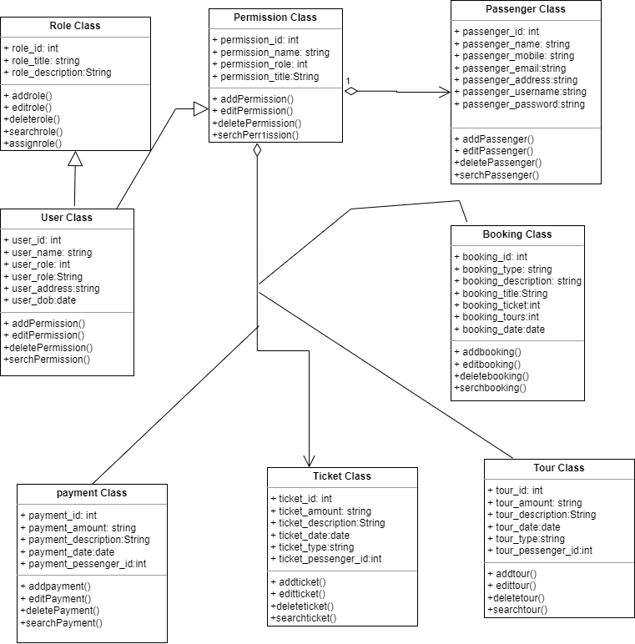

Figure 4.1

## 

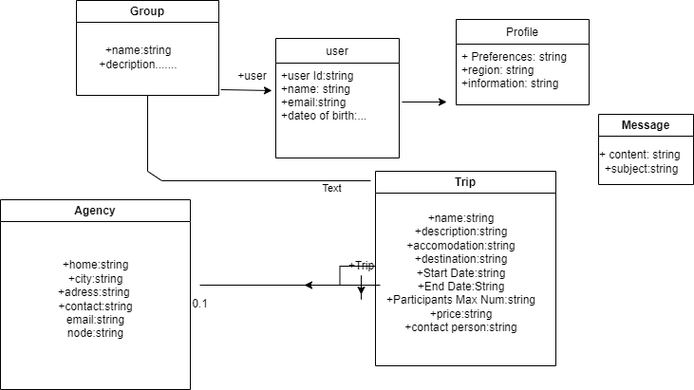Figure 4.2

## Sequence Diagrams

This diagram includes all the Sequence diagrams of the functional requirements of Traveler Assistant system project along with the aggregated Sequence diagram

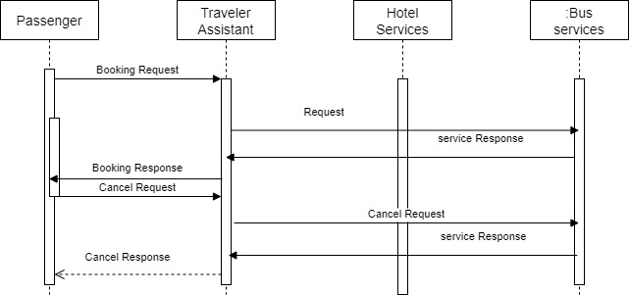Figure 4.3

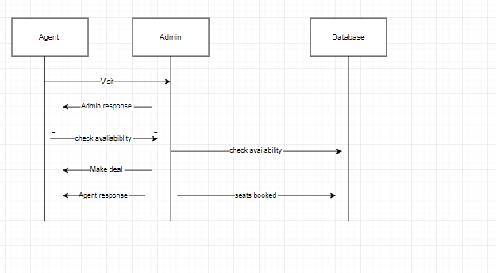

Figure 4.4

## ERD

## Entity Relationship diagram with complete relationship with dependancies of our assistant traveller system project

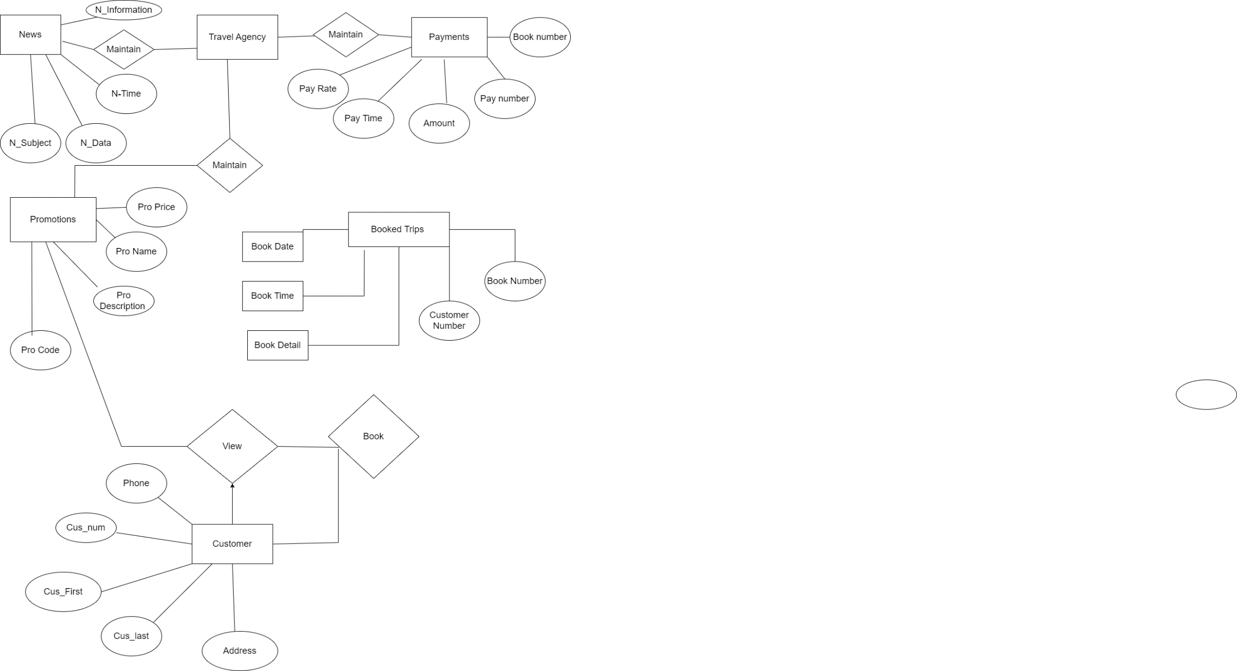

## Figure 4.5